Realtimepoints Fuction app

IAC(folder)

1)dev.tfvars

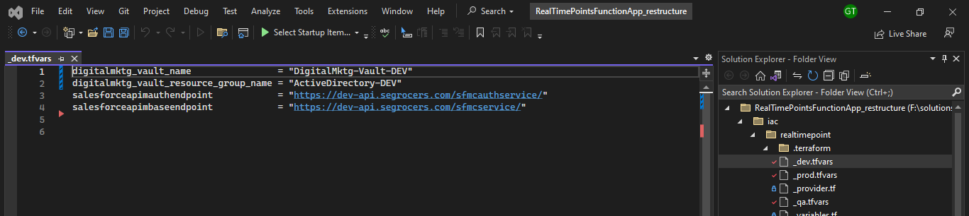

2)_prod.tfvars

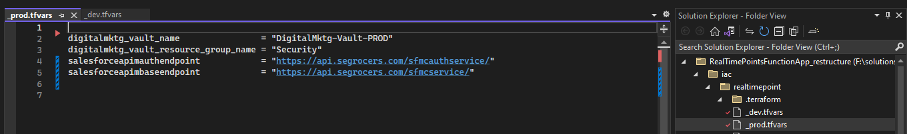

3)_qa.tfvars

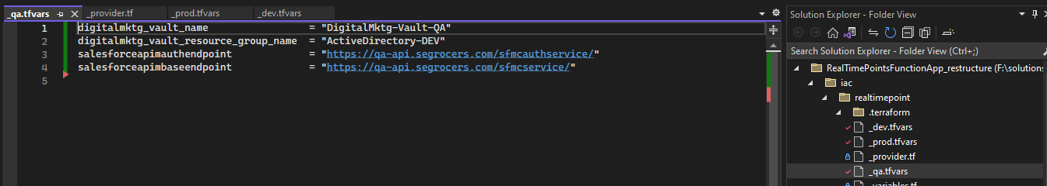

4)function_app.tf

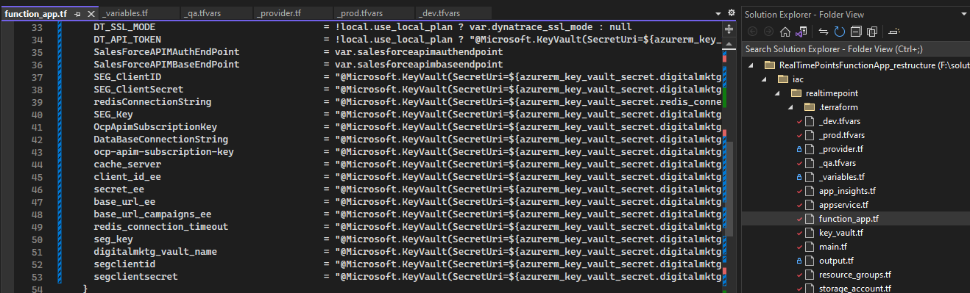

5)key_vault

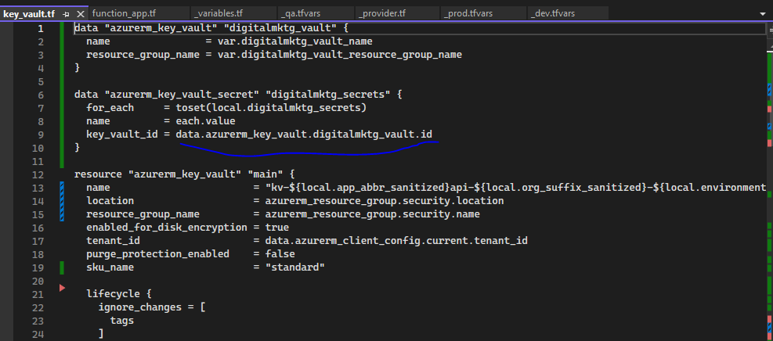

6)main_tf

